Filter Design Results
Generated by: http://www-users.cs.york.ac.uk/~fisher/mkfilter

Summary
You specified the following parameters:
filtertype | = | Butterworth
passtype | = | Highpass
ripple | =
order | = | 2
samplerate | = | 167564
corner1 | = | 1000
corner2 | =
adzero | =
logmin | =

Results
Command line: /www/usr/fisher/helpers/mkfilter -Bu -Hp -o 2 -a 5.9678689933e-03 0.0000000000e+00
raw alpha1 = 0.0059678690
raw alpha2 = 0.0059678690
warped alpha1 = 0.0059685683
warped alpha2 = 0.0059685683
gain at dc : mag = 0.000000000e+00
gain at centre: mag = 7.261062054e-01 phase = 0.5000000000 pi
gain at hf : mag = 1.026869243e+00 phase = 0.0000000000 pi

S-plane zeros:
0.0000000000 + j 0.0000000000 2 times

S-plane poles:
-0.0265176505 + j -0.0265176505
-0.0265176505 + j 0.0265176505

Z-plane zeros:
1.0000000000 + j 0.0000000000 2 times

Z-plane poles:
0.9734914290 + j -0.0258237849
0.9734914290 + j 0.0258237849

Recurrence relation:
y[n] = ( 1 * x[n- 2])
+ ( -2 * x[n- 1])
+ ( 1 * x[n- 0])

+ ( -0.9483524302 * y[n- 2])
+ ( 1.9469828580 * y[n- 1])

Ansi ``C'' Code
/* Digital filter designed by mkfilter/mkshape/gencode A.J. Fisher
Command line: /www/usr/fisher/helpers/mkfilter -Bu -Hp -o 2 -a 5.9678689933e-03 0.0000000000e+00 -l */

#define NZEROS 2
#define NPOLES 2
#define GAIN 1.026869243e+00

static float xv[NZEROS+1], yv[NPOLES+1];

static void filterloop()
{ for (;;)
{ xv[0] = xv[1]; xv[1] = xv[2];
xv[2] = next input value / GAIN;
yv[0] = yv[1]; yv[1] = yv[2];
yv[2] = (xv[0] + xv[2]) - 2 * xv[1]
+ ( -0.9483524302 * yv[0]) + ( 1.9469828580 * yv[1]);
next output value = yv[2];
}
}

Magnitude (red) and phase (blue) vs. frequency
- x axis: frequency, as a fraction of the sampling rate (i.e. 0.5 represents the Nyquist frequency, which is 83782 Hz)
- y axis (red): magnitude (linear, normalized)
- y axis (blue): phase

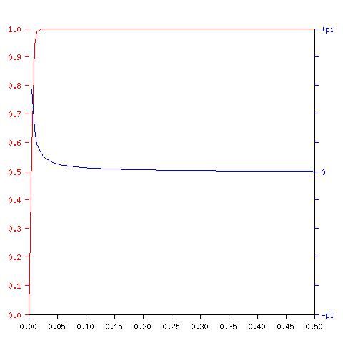
Impulse response
- x axis: time, in samples (i.e. 167564 represents 1 second)
- y axis (red): filter response (linear, normalized)

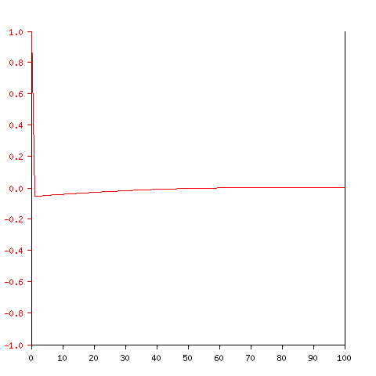
Step response
- x axis: time, in samples (i.e. 167564 represents 1 second)
- y axis (red): filter response (linear, normalized)
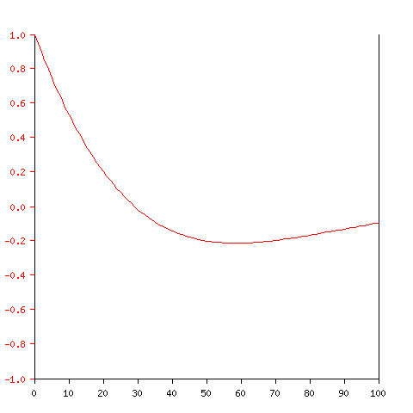
Tony Fisher fisher@minster.york.ac.uk

